**Automatic Ambubag Ventillator**

**Parts for making the entire system-**

1. Ambubag



1. Dc motor

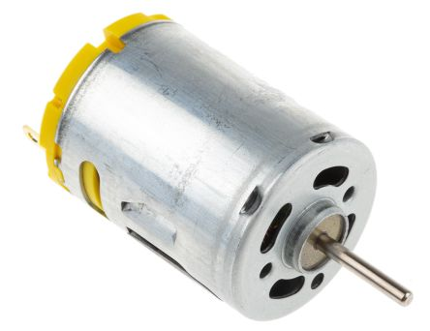

1. Pressure gauge

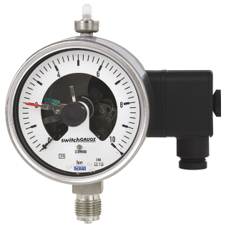

1. Arduino Uno

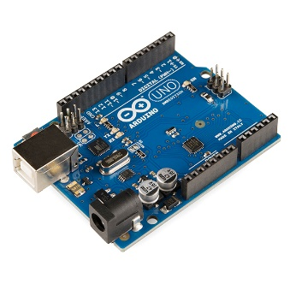

1. Motor driver

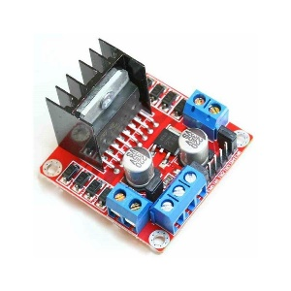

1. Cables & some mechanical accessories like motor gears & etc

**Working principle-**

The conventional ambu bag consists of several parts like inlet & out let valves, back up bags and main ventilation. When the vantillation bag is squeezed manually, the air enters to the mouth of patient. Because of having oneway valve close to the mouth mask, there is no possibility of backfiring of exhaled air from the patient. Also, it is possible to connect the main bag to the oxygen cylinder. Though its more hygienic, simple & effective, the main drawback of this conventional bag is, its hand driven or have to drive manually.

Here, our proposed system is to squeeze the ventilation bag using microcontroller driven automatic system. The microcontroller, which will be coded according to the requirement, drives the motor and this motor will drive the total mechanical system for squeezing the ventilation bag. Also, the pressure gauge signal from the oxygen inlet valve can give alarm when the pressure is more or less then its required level.